2) Navigate to the home directory.

3) Create a new directory.

4) List the contents of a directory.

5) Change the current directory.

6) Create a new empty file.

7) View the contents of a file.

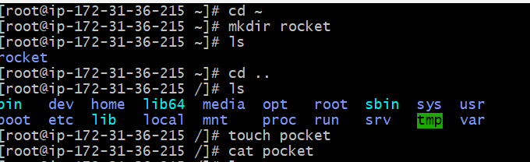

10) Rename a file.

11) Delete a file.

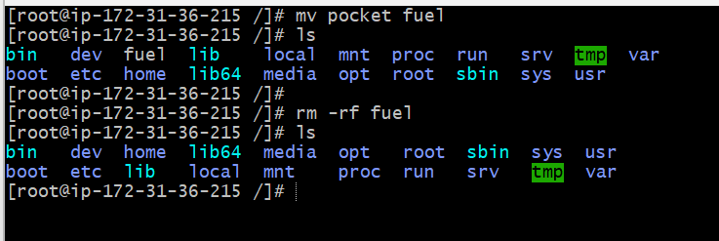

11) Delete a file.

12) Grant or revoke permissions on a file or directory.

13) View the current date and time.

14) Check the system uptime.

15) View the running processes.

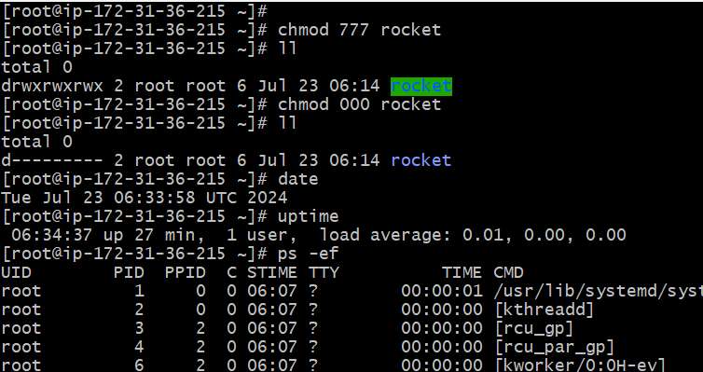

19) Create a symbolic link.

20) Search for files using the find command.

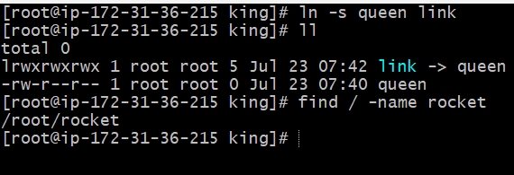

21. Compress and decompress files using tar.

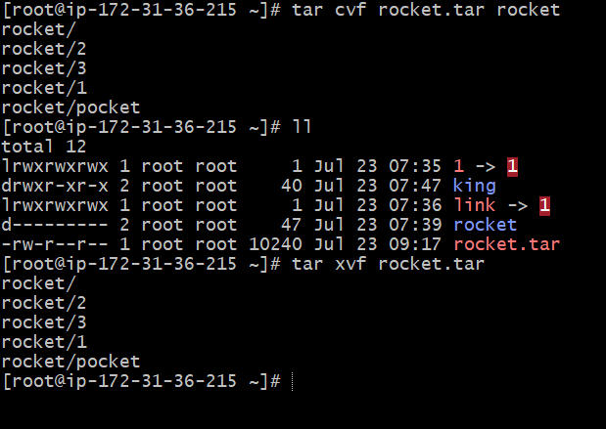

22. Monitor system resources with top or htop.

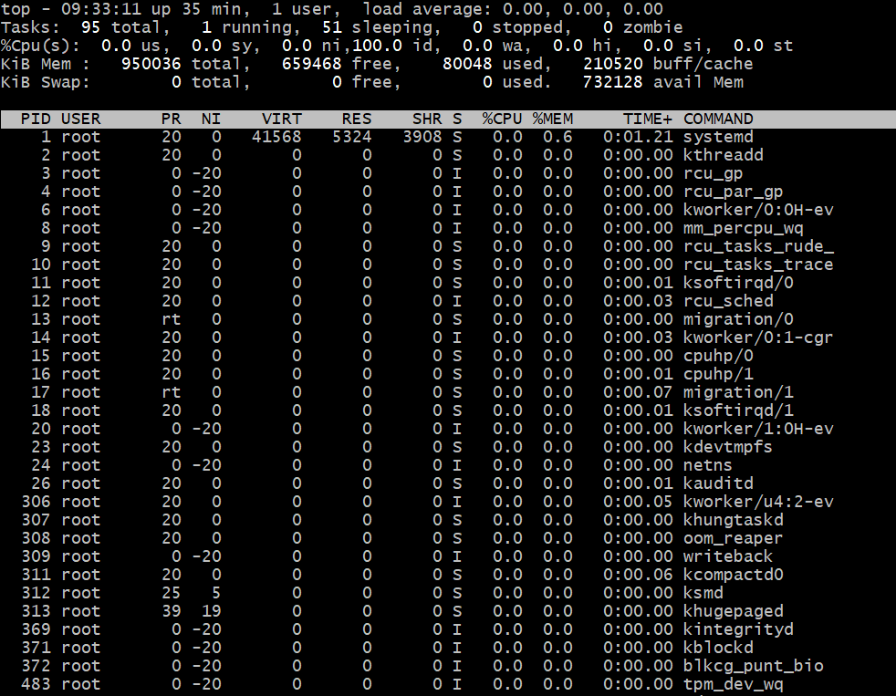

25. Monitor log files using tail or grep.

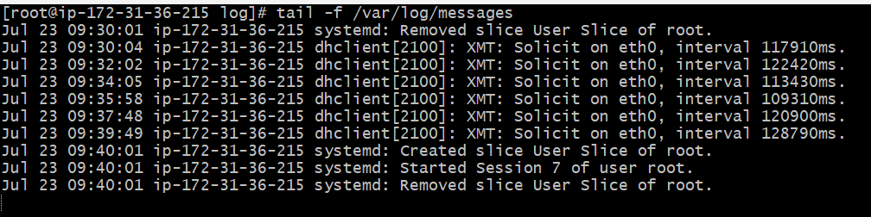

30) Print specific columns from a delimited file.

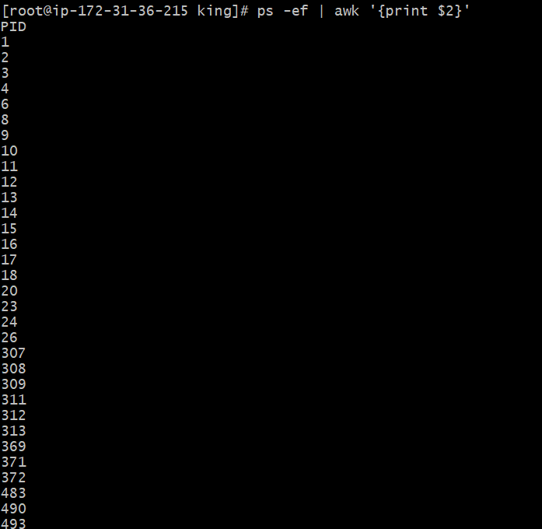

32) Calculate and print the average, sum, or other statistics of a column.

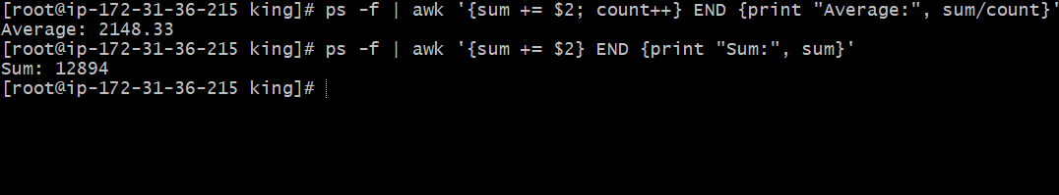

9) move a file to another location.

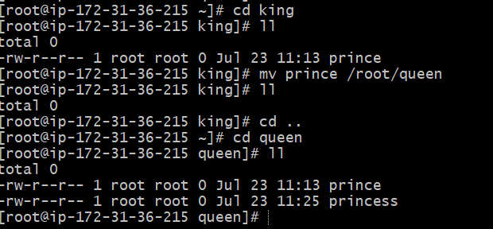

8) Copy a file to another location.

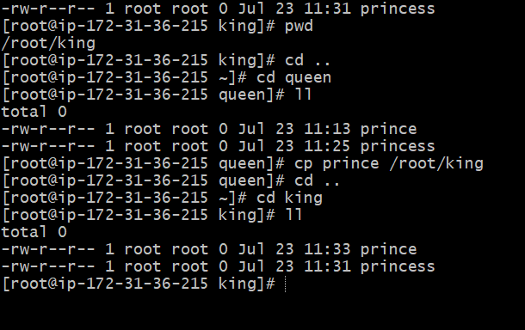

16) Kill a running process.

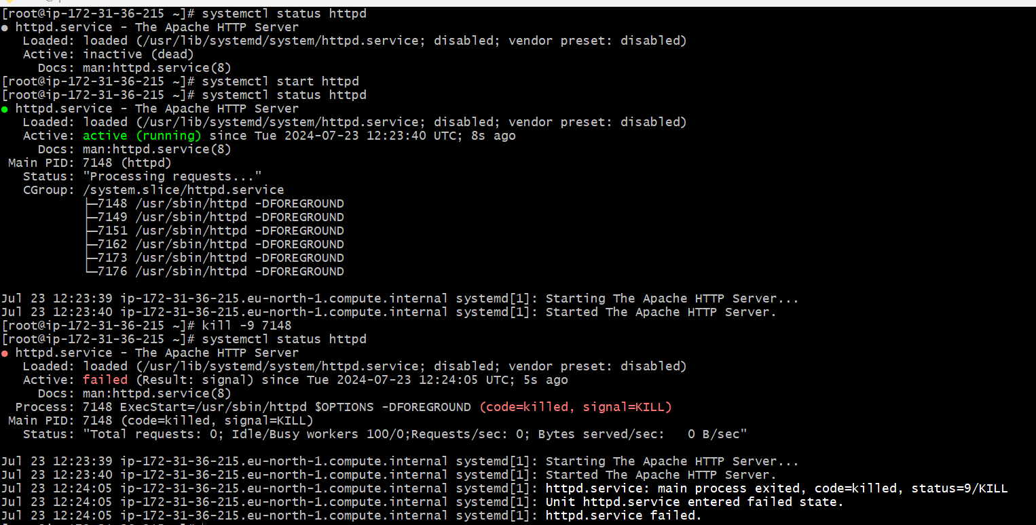

40) Print only specific lines from a file.

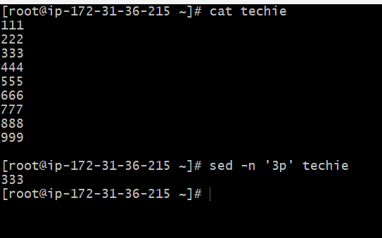

38) Delete specific lines based on a pattern or line number.

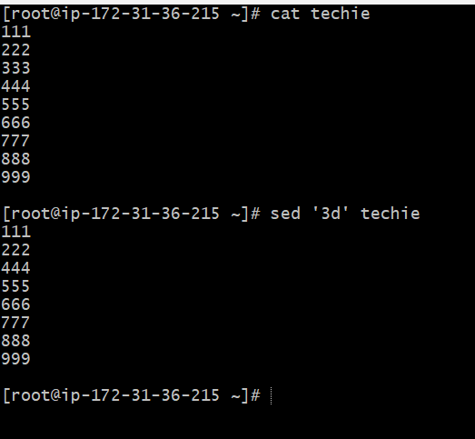

17) Install a package using the package manager (e.g., apt or yum).

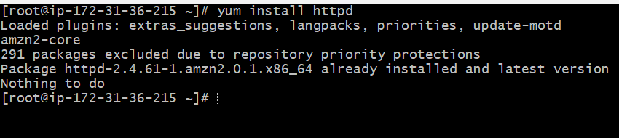

44) Copy file from linux to windows machine



18) Update the system packages.

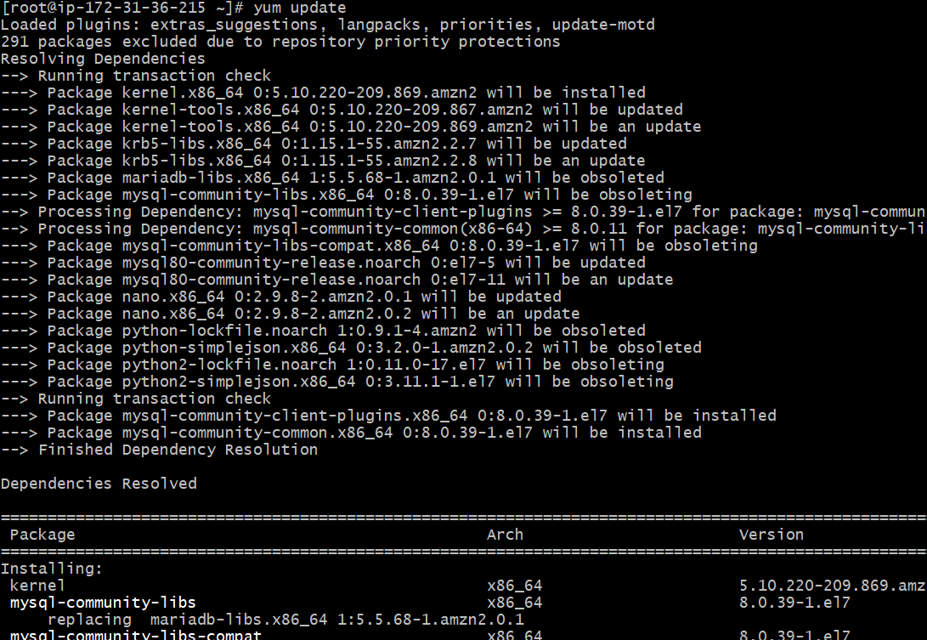

24) Set up SSH password less authentication.

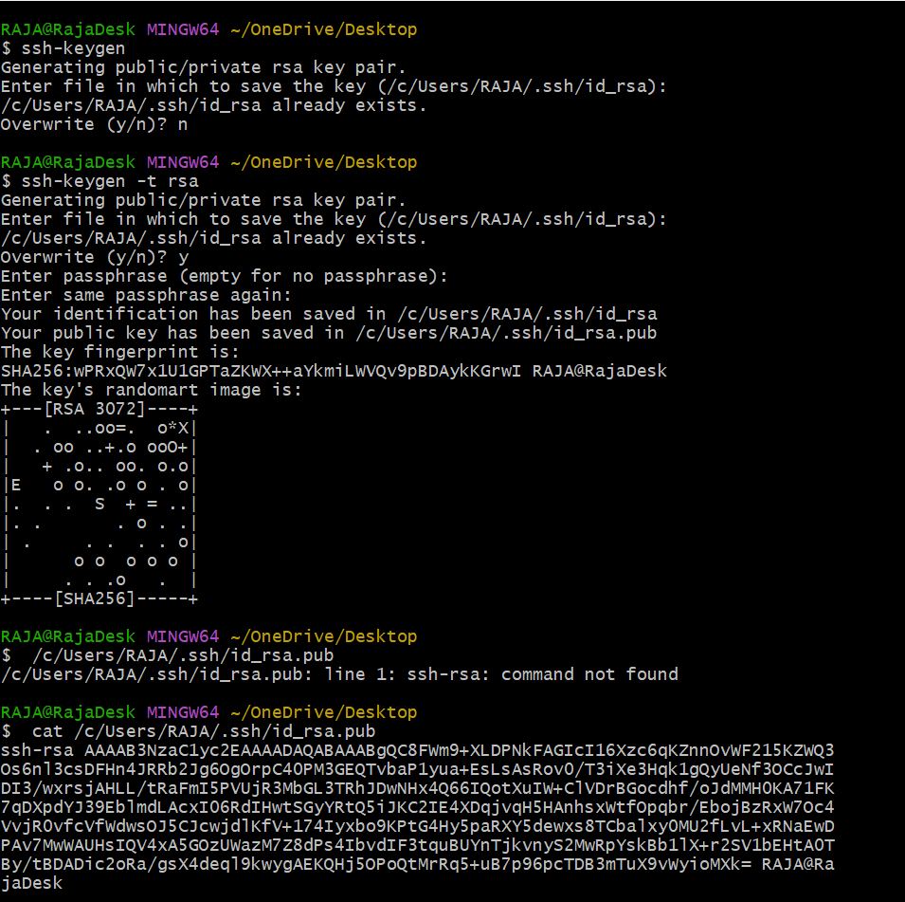

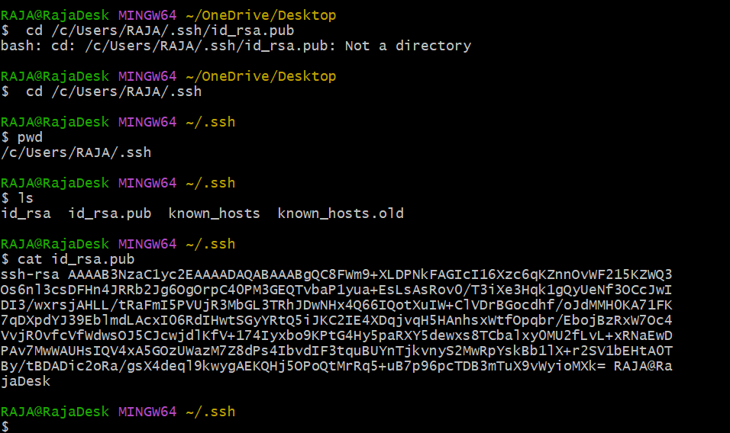

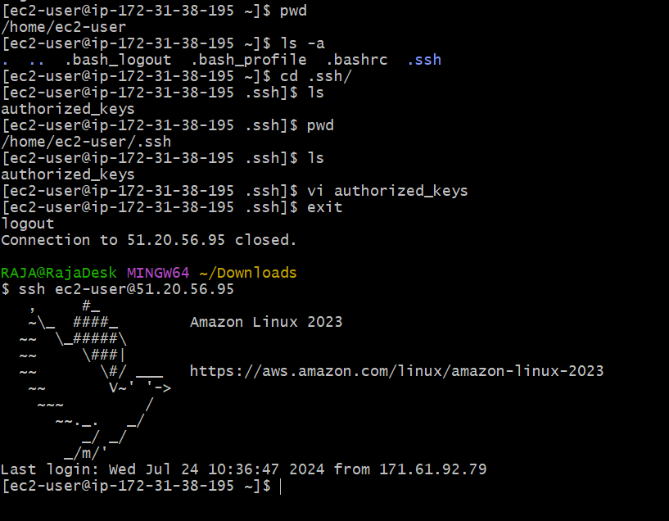

27) Configure and secure a MySQL Database.

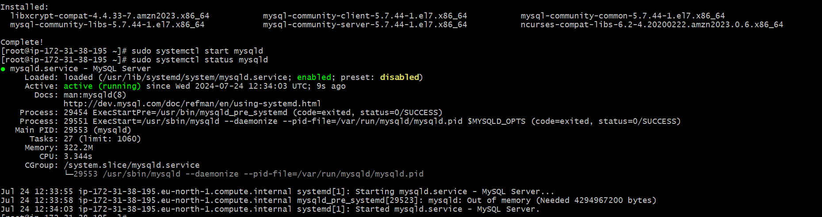

26) Set up a web server (e.g. Apache or Nginx)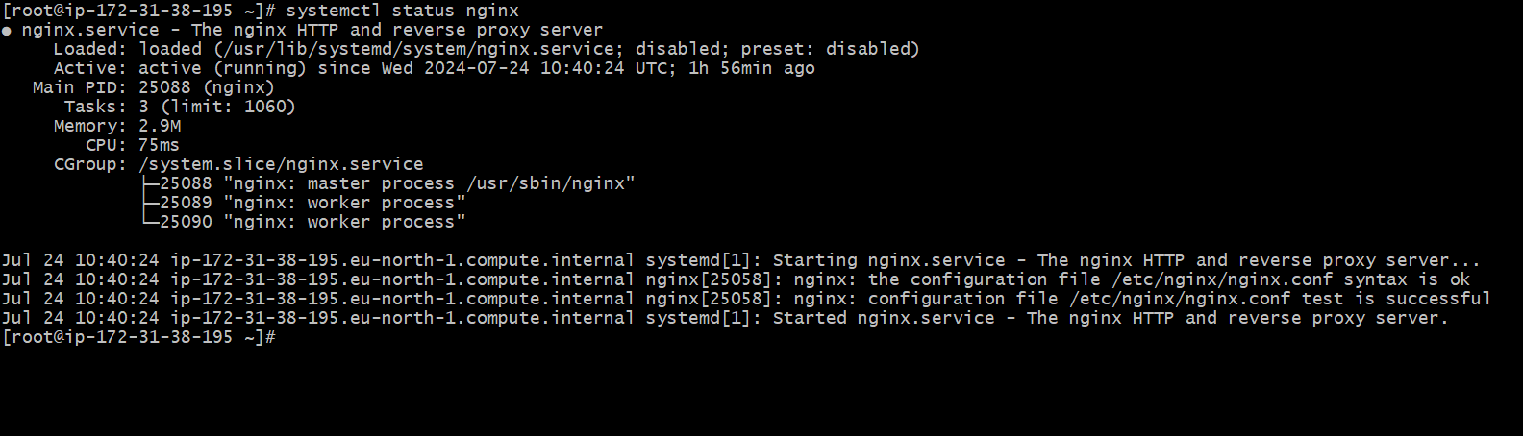,

36) Merge multiple files based on a common field or column.

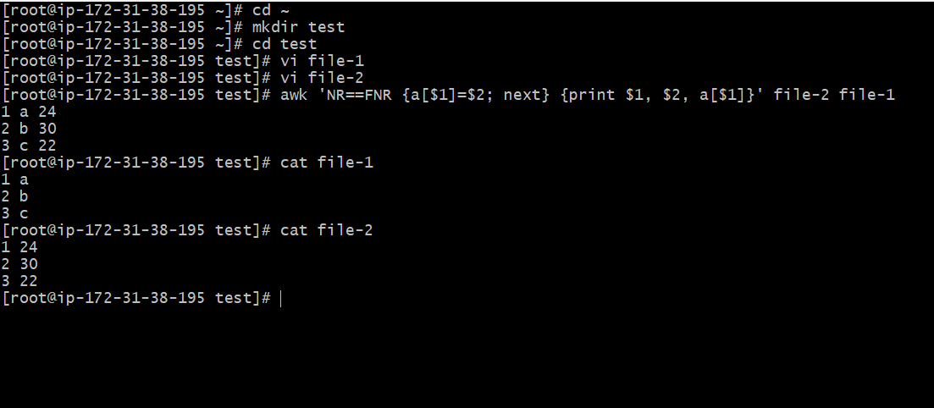

41) Delete leading or trailing whitespace from lines.

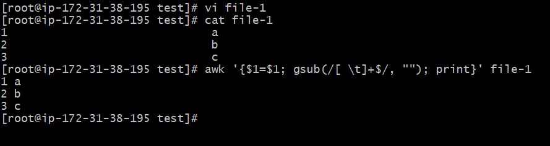

34) Count the occurrences of a specific pattern in a file.

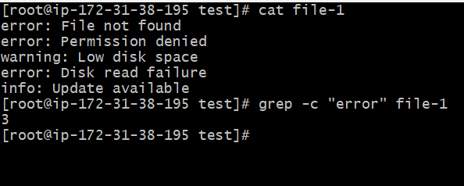

39) Append or insert text before or after a specific pattern or line.

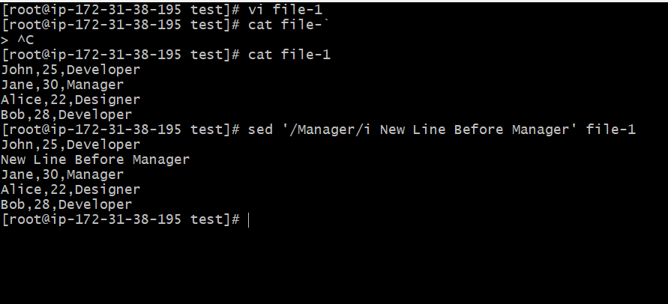

/Manager/: Specifies the pattern to search for.

i: Insert text before the matched line.

New Line Before Manager: The text to insert.

35) Sort lines based on a specific field or column.

To sort the lines based on the first field (name) in ascending order:

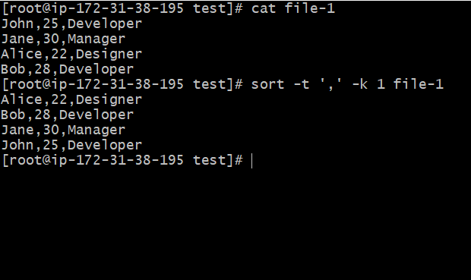

31) Filter and print lines based on a specific pattern or condition.

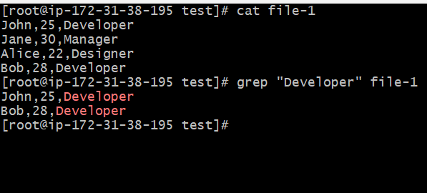

43) Join multiple lines into a single line or split a line into multiple lines.

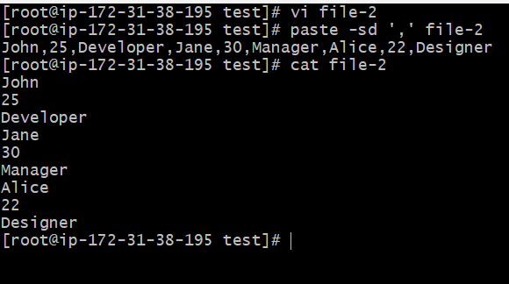

37) Substitute text in a file using search and replace.

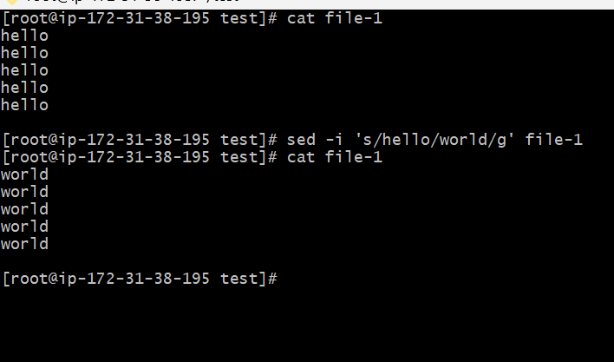

42) Edit files in-place, making changes directly to the file.

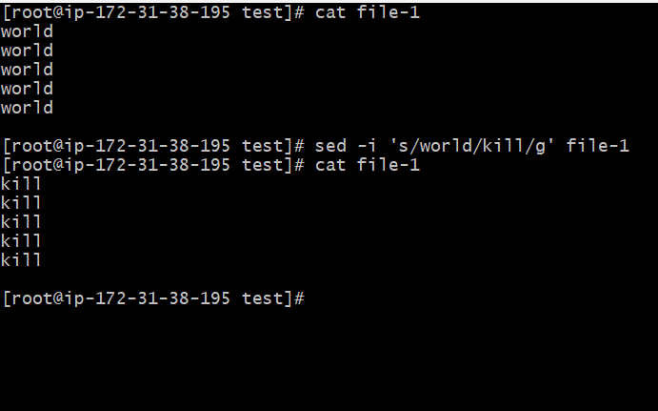

23) Create and manage user groups.

